EXPERIMENT 2: WAVEFORM GENERATION

Objective: To generate sinusoidal, triangular and square waves using Scilab.
Pre Session test:
- The Taylor series expansion for sin(x) is
- X+X^2+X^3+….
- X-X^3+X^5-+…..
- X+X^3+X^5+…
- X-X^2+X^3-+……

- Integration of a square wave results in a
- Square wave
- Sine wave
- Triangular wave
- Cosine wave

- Conversion of sine wave to square wave is achieved through
- Integrator
- Differentiator
- Schmitt Trigger
- None of the above

Procedure:
Log on to the system. Book a slot. Answer all the questions in the pre session test. If all the answers are correct, a link will be activated to access the system.

Once the link is active,

- Load the sine.sce file in Scilab.
- Go to Execute->Load into Scilab or press Ctrl-L
- Enter the amplitude of the sine wave which needs to be produced.
E.g.:
Enter the amplitude of the sine wave 2 (Enter the desired amplitude here)
A = 2
A should print the value of the amplitude requested by the user.

- A graphical representation of the sine wave appears on the plot window.
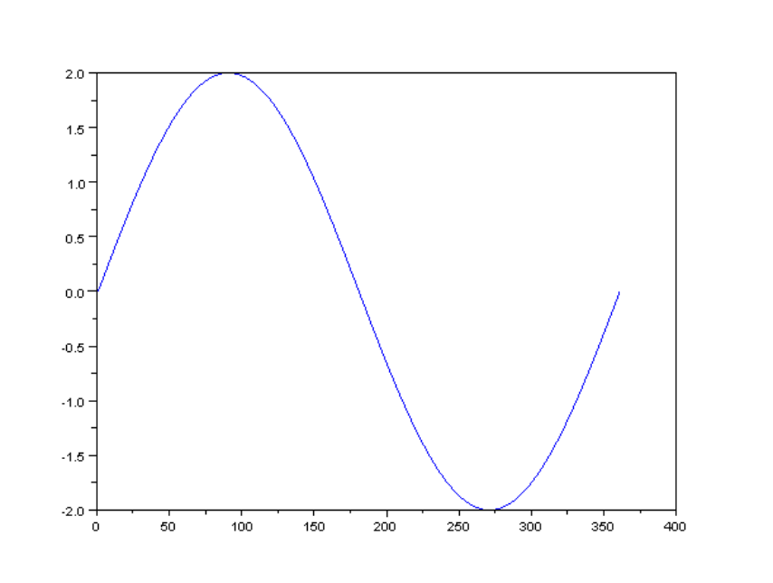

- Next, load the square.sce file in Scilab.
- Execute the code.
- Enter the desired amplitude for the square wave.
E.g.:
Enter the amplitude of the square wave 2 (Enter the desired amplitude here)
A = 2
A should print the value of the amplitude requested by the user.
- A plot of square wave appears on the plot window.
- Rotate the waveform to get a good representation of the square wave.

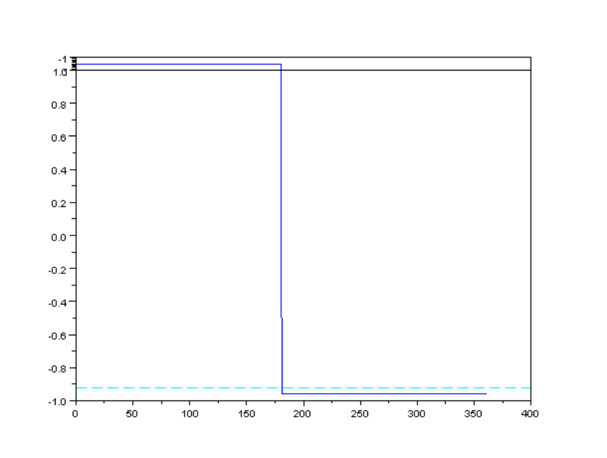

- Repeat the procedure with triangle.sce.
- You will get a triangular wave on the graphic window.

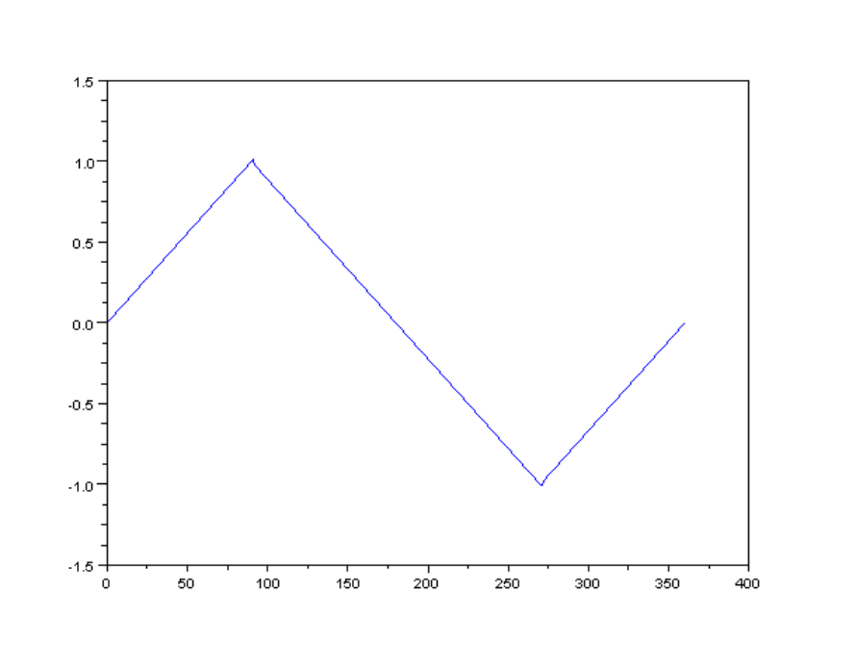

Post Session work
- Generate a waveform which is a combination of sine, square and triangle i.e. the wave should be 1 cycle of sine followed by 1 cycle of square followed by 1 cycle of triangle. Repeat the experiment by having the square wave and triangular wave as the first signal.

- Generate a sinc waveform using Scilab.

